Meta Title: Creative graphic designing services | Reach out to us today!
Meta Description: If you are looking for experts who provide creative graphic designing services, we are ready to help you. We can enhance your digital and print designs.
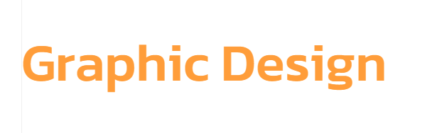

Graphic Designing Services that drive results!
At The Neo Solutions, we create graphic designs that are attractive and impacting. With our graphic designing services, you can leave a permanent impression on your customers. If you want to promote your brand, product, and services anywhere or everywhere, let us create the right graphic designs for you.
Call us today!

Experience the best Graphic designing services

Designs speak louder than words
The value of your business’ designs, catalogs, logo, digital marketing pieces, and printed sales depends on the graphic design. The designs must represent your business outlook and value rightly. We are the experts in providing impactful graphic designing services. With our designed graphics, you can easily communicate your brand to your desired audience. We do:
- Business Identity Designs | - Digital Media Designs | - Print Media Designs

Ours is the leading graphic design company!
We offer graphic designing services for both B2B and B2C spaces. Unlike any other graphic design agency, we fulfill all your design requirements and work as an extension of your digital marketing and branding teams. We have years of experience in creating creative graphic designs for diverse needs of large enterprises and startups. What’s more, our graphic designers have a strong grip over the latest and classic technical graphic design tools.

Our graphic design process includes:

Consultation
First, we have a consultation session where we take time to understand your audience and brand

Exploration
We explore creative ideas & designs that can help you promote your business quickly in the market

Planning
We plan the designs by keeping your competitive advantage in focus for better business reach

Designing
We use our expertise and technical tools to design the best graphic solutions for your business

Our Design Capabilities are available for these industries:
Retail | Manufacturing | Education
Healthcare | Entertainment | Hospitality
Tourism | Real Estate | Travel
Food | Banking | It Industry

Get ahead with our graphic designing services!
Our graphic designs stand strong throughout the years! We provide the best graphic designing services for small business owners who want to outmatch their competitors. Because we have a passion for creating graphics that meet and exceed audience expectations, we can help you brand your business. What’s more, we only offer white label graphic design services. With our help, you can grow your social media platforms, drive brand engagement, and streamline your marketing campaigns. We can design anything and everything for you, including:
- Book Covers | - E-books layout | - Email Templates
- Business Cards | - Flyers & Posters | - Brochures
- Logos | - Packaging | - Labels
- Presentations | - Food Menus | - Catalogs
- Brand guides | - Brand identity | - Social Media posts
- Magazines | - Stationary | - Infographics
- Letterheads | - Print Graphics | - Product catalogs

Why choose The Neo Solutions?
We are experts of creative graphic designing services! You should know that the success of your business depends on the graphic designs you use for print and digital marketing. If the design does not resonate with your brand’s message or audience, it will not get you any sales or leads. At The Neo Solutions, we help your business thrive with graphic designs that are eye-catchy and amazing. We can help you:
Establish Visual Brand Identity | We use consistent colors and designs and present them with elegance. So, when your audience comes across brochures, cards, and digital posts, it helps them recognize the brand.
Strengthen Business Advertising | Advertising is only effective if the visuals are impactful and creative. So, we use brilliant ideas and good graphics to enhance the advertising of your business’ products and services.
Increase your business sales | Our graphic designs turn your audience into customers with their appeal and message. If you want to enhance your business sales, let our experts design all the graphics for you.

Have a graphic design project that is worrying you?

Let us help you!

